Template Method Pattern
# Source: AI Source: Provided by: [Data Path: Persons Table -> ID Column: 1, Name_En Column: Motasem Essam] -> From: [ChatGPT] on [1/23/2026]
The Template Method Pattern defines the skeleton of an algorithm in a method, while allowing subclasses to override specific steps without changing the overall structure.
👉 Think of it like a recipe: the steps are fixed (boil, cook, serve), but the ingredients can vary.

🔑 Key Points
# Source: AI Source: Provided by: [Data Path: Persons Table -> ID Column: 1, Name_En Column: Motasem Essam] -> From: [ChatGPT] on [1/23/2026]
• Defines a fixed algorithm structure
• Allows customization of certain steps
• Promotes code reuse
• Uses inheritance

❌ Bad Example
# Source: AI Source: Provided by: [Data Path: Persons Table -> ID Column: 1, Name_En Column: Motasem Essam] -> From: [ChatGPT] on [1/23/2026]
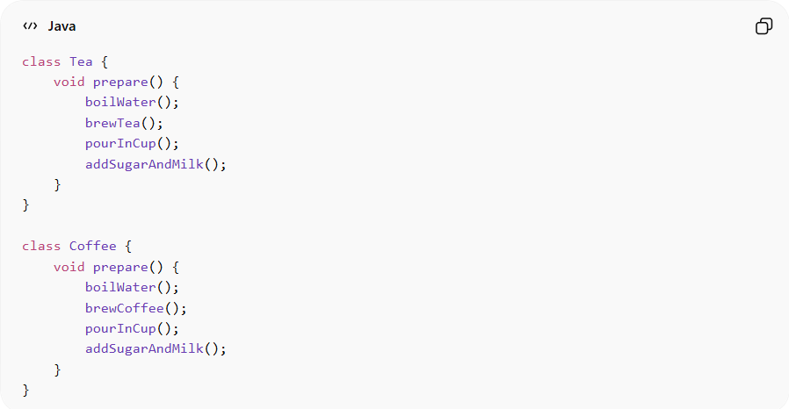
class Tea {
void prepare() {
boilWater();
brewTea();
pourInCup();
addSugarAndMilk();
}
}

class Coffee {
void prepare() {
boilWater();
brewCoffee();
pourInCup();
addSugarAndMilk();
}
}
Problems:
• Duplicate code (boiling, pouring)
• Hard to maintain or update shared steps
• Violates DRY principle

✅ Good Example
# Source: AI Source: Provided by: [Data Path: Persons Table -> ID Column: 1, Name_En Column: Motasem Essam] -> From: [ChatGPT] on [1/23/2026]
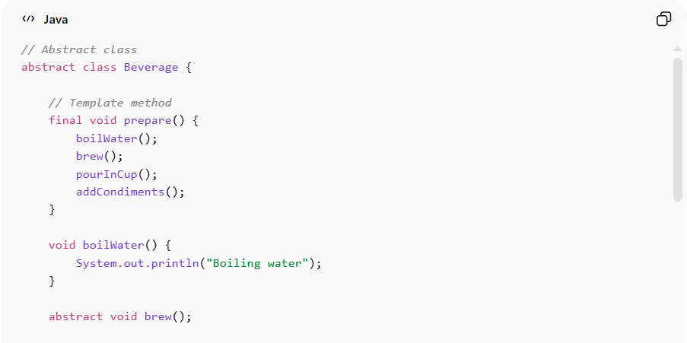
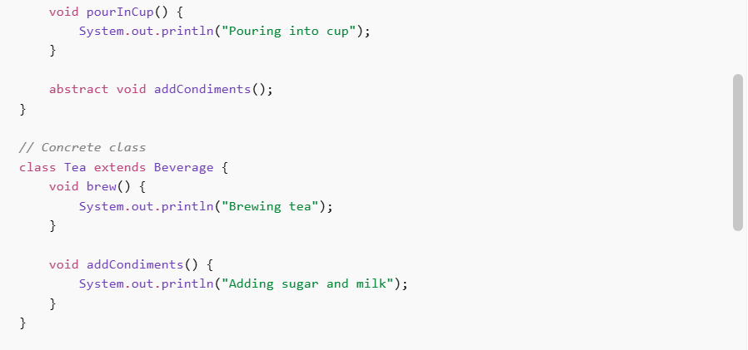
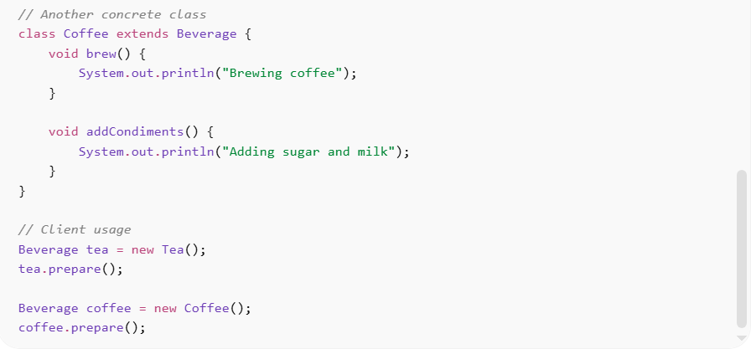
// Abstract class
abstract class Beverage {

// Template method
final void prepare() {
boilWater();
brew();
pourInCup();
addCondiments();
}

void boilWater() {
System.out.println("Boiling water");
}

abstract void brew();

void pourInCup() {
System.out.println("Pouring into cup");
}

abstract void addCondiments();
}

// Concrete class
class Tea extends Beverage {
void brew() {
System.out.println("Brewing tea");
}

void addCondiments() {
System.out.println("Adding sugar and milk");
}
}

// Another concrete class
class Coffee extends Beverage {
void brew() {
System.out.println("Brewing coffee");
}

void addCondiments() {
System.out.println("Adding sugar and milk");
}
}

// Client usage
Beverage tea = new Tea();
tea.prepare();

Beverage coffee = new Coffee();
coffee.prepare();
Benefits:
• Eliminates code duplication
• Maintains consistent algorithm structure
• Allows flexibility in specific steps
• Improves code organization

⚡ Advantages
# Source: AI Source: Provided by: [Data Path: Persons Table -> ID Column: 1, Name_En Column: Motasem Essam] -> From: [ChatGPT] on [1/23/2026]
• Promotes code reuse
• Enforces algorithm consistency
• Makes code clean and maintainable
• Allows subclasses to customize behavior

⚠️ Disadvantages
# Source: AI Source: Provided by: [Data Path: Persons Table -> ID Column: 1, Name_En Column: Motasem Essam] -> From: [ChatGPT] on [1/23/2026]
• Uses inheritance → less flexible than composition
• Changes to template affect all subclasses
• Can lead to rigid designs

🛠️ Use Cases
# Source: AI Source: Provided by: [Data Path: Persons Table -> ID Column: 1, Name_En Column: Motasem Essam] -> From: [ChatGPT] on [1/23/2026]
• Data processing pipelines
• Game development – game loop structure
• Frameworks – defining standard workflows
• File processing – reading, processing, saving files

